Table of Contents
1 Overview 2
2 Privileged Account Correlation 2
3 Privileged Account Identification 2
4 Privileged Account Lock/Disable Status 3
5 Privileged Entitlement Identification 3
6 Privileged Entitlement Manual Override 4
7 Privileged Entitlement Extended Attributes 5
8 Privileged Role Extended Attributes 5
9 Privileged Account Type Extended Attribute 5
10 Privileged Account Termination 5
11 Privileged Account Validations 5
12 Dynamic Scope and QuickLink 6
13 Manage User Access QuickLink Filtering 6
14 Manage Privileged Access QuickLink Filtering 6
15 Privileged Account Access Request Flow 7
16 Privileged Account Bypass Manager Approval 8
17 Privileged Account Certification 8
18 Privileged Account Expiration Notification 8
19 Privileged Account Dependency on Features 9

Document Revision History
Version | Date | Status | Author | Summary of Changes
Version 1 | 3/2/18 |  | Rohit Gupta
Version 2 | 6/1/018 |  | Cathy Mallet | Minor editorial cleanup

Overview
This document outlines the design and technical implementation for the Privileged Account Feature within Accelerator Pack.

Privileged Account Correlation
Privileged Accounts can be correlated using two types of String Format. One is with String Comparison Operation and the other one is without String Comparison Operation. The name of the attribute that is used for this definition on an application is “accountAttrExpression”. The same attribute is used for regular/primary accounts.

The “Rule-Framework-Correlation” rule must be selected as a correlation rule on an application. This rule is automatically set from the Self Service Onboarding Wizard.

Please Note: The same rule correlates service/non-interactive/shared accounts to service cubes first and then correlates privileged/secondary/interactive, and regular/primary accounts to authoritative source cubes. Please see the Accelerator Pack Aggregation Document section Account Correlation Identification and the Accelerator Pack Aggregation Document rule “Rule-Framework-Correlation” section Aggregation Data Flow.

Privileged Account Identification
Account privileged status can be identified using String Format with Comparison Operation or String Format with Java Regular Expression. The name of the attribute that is used for this definition on an application is “privilegedAccountAttrExpression”.

The “Rule-Framework-RapidAppOnBoarding-Customization-Rule” rule must be selected as a customization rule on an application. This rule is automatically set from the Self Service Onboarding Wizard.

During aggregation, the “Rule-FrameWork-PSA” rule promotes the link “IIQPrivileged” attribute status to an extended searchable link attribute “psaAccount”.

Here is an example of String Format with Operation: “[Schema Attribute Name]#IIQPrivileged#[Schema Attribute Value]#IIQPrivileged#[Operation]”. This format is automatically set from the Self Service Onboarding Wizard.

String Tokens and Separators | Description
[Schema Attribute Name] | Some applications may support multiple Object Type Schemas, for example, Delimited File and JDBC connectors. The object type must be prefixed with the Application Schema Attribute Name
#IIQPrivileged# (Token Separator) | Token to Separate Identity Schema Attribute Name and Schema Attribute Value
[Schema Attribute Value] | Application Schema Attribute Value
#IIQPrivileged# (Token Separator) | Token to Separate Schema Attribute Value and Operation
[Operation] | STARTSWITH  ENDSWITH  CONTAINS  EQUALS

Here is an example of String Format with Java Regular Expression “[Schema Attribute Name]#IIQPrivileged#[Java Regular Expression]”.

String Tokens and Separators | Description
[Schema Attribute Name] | Application Schema Attribute Name
#IIQPrivileged# (Token Separator) | Token to Separate Application Schema Attribute Name and Java Regular Expression
[Java Regular Expression] | This is executed against the Application Schema Attribute Value obtained from the Application Schema Attribute Name on the “Link” Object

Please see the Accelerator Pack Aggregation document for the customization rule “Rule-Framework-RapidAppOnBoarding-Customization-Rule”, in the section on Aggregation Data Flow

Privileged Account Lock/Disable Status
Please see the Accelerator Pack Aggregation document sections on Account Disable Status Identification and Account Lock Status Identification.

Privileged Entitlement Identification
Entitlement privileged status can be identified using String Format with Comparison Operation or String Format with Java Regular Expression. The name of the attribute that is used for this definition on an application is “privilegedEntAttrExpression”.

The “Rule-FrameWork-Promote-Managed-Attribute” rule must be selected as “Managed Entitlement Customization Rule” on an application. This rule is automatically set from the Self Service Onboarding Wizard.

During aggregation, the “Rule-FrameWork-Promote-Managed-Attribute” rule sets the entitlement attribute “entPrivileged” to either “True” or “False” based on privileged entitlement attribute “privilegedEntAttrExpression” identification. This rule executes only for new entitlements.

The “Rule-FrameWork-Group-Refresh” rule must be selected manually on all group type aggregations of an application. This rule executes for both new and old entitlements. This rule sets the entitlement attribute “entPrivileged” to either “True” or “False” based on privileged entitlement attribute “privilegedEntAttrExpression” identification.

Here is an example of String Format with Operation “[Object Type(Optional).Schema Attribute Name]#IIQEntitlementPrivileged#[Schema Attribute Value]#IIQEntitlementPrivileged#[Operation]”. This format is automatically set from the Self Service Onboarding Wizard.

String Tokens and Separators | Description
[Object Type(Optional).Schema Attribute Name] | Some applications may support multiple Object Type Schemas for example Delimited File and JDBC connectors. The object type must be prefixed with the Application Schema Attribute Name
#IIQEntitlementPrivileged# (Token Separator) | Token to Separate Identity Schema Attribute Name and Schema Attribute Value
[Schema Attribute Value] | Application Schema Attribute Value
#IIQEntitlementPrivileged# (Token Separator) | Token to Separate Schema Attribute Value and Operation
[Operation] | STARTSWITH  ENDSWITH  CONTAINS  EQUALS

Example of String Format with Java Regular Expression “[Schema Attribute Name]#IIQEntitlementPrivileged#[Java Regular Expression]”.

String Tokens and Separators | Description
[Object Type(Optional).Schema Attribute Name] | Some applications may support multiple Object Type Schemas, for example, Delimited File and JDBC connectors. The object type must be prefixed with the Application Schema Attribute Name
#IIQEntitlementPrivileged# (Token Separator) | Token to Separate Application Schema Attribute Name and Java Regular Expression
[Java Regular Expression] | This is executed against the Application Schema Attribute Value obtained from Application Schema Attribute Name on the “Link” Object

The IdentityIQ Entitlement Catalog interface can be used to mark entitlements manually as privileged if they cannot be identified programmatically.

Please see the Accelerator Pack Aggregation document for managed entitlement customization rule “Rule-FrameWork-Promote-Managed-Attribute” and group refresh rule “Rule-FrameWork-Group-Refresh” in the section Aggregation Data Flow.

Privileged Entitlement Manual Override

This sub-feature is mainly used for an operations team to override the tagging of privileged entitlements programmatically. The IdentityIQ Entitlement Catalog interface can be used to mark privileged entitlements as non-privileged. This can be done by putting the value “FALSE” for an extended attribute “Privileged Entitlements”. To ensure this value is not overridden next time when the group refresh rule “Rule-FrameWork-Group-Refresh” executes, the “Manual Override” attribute must be set to “TRUE”. By default, an empty value for this attribute means “FALSE”.

Privileged Entitlement Extended Attributes
The extended attribute on the ManagedAttribute ObjectConfig object by display name “Privileged Entitlement” and internal name “entPrivileged” indicates if an entitlement is privileged or not. This attribute is a string type that could be either “True” or “False”.

The extended attribute on the Bundle ObjectConfig object by display name “Privileged Role Account Types” and internal name “appaccountType” must be populated using Role Administration Page. Once populated, this attribute value is used for account type matching validation with the Link objects on Identity. The attribute can be multiple account type values, it supports comma separated values for example “Tier 1”, “Tier 2”. These are just sample values, any account type naming convention can be used.

Privileged Role Extended Attributes
The extended attribute on the Bundle ObjectConfig object by display name “Privileged Role” and internal name “rolePrivileged” indicates if a role is privileged or not. This attribute is a string type that could be either “True” or “False”.

The extended attribute on the ManagedAttribute ObjectConfig object by display name “Privileged Entitlement Account Types” and internal name “appaccountType” must be populated using Role Administration Page. Once populated, this attribute value is used for account type matching validation with the Link objects on Identity. The attribute can be multiple account type values, it supports comma separated values for example “Tier 1”, “Tier 2”. These are just sample values, any account type naming convention can be used.

Privileged Account Type Extended Attribute
The extended attribute on the Link ObjectConfig object by display name “Account Type” and internal name “appaccountType” must populated by Global Account Mappings Rule. Once populated, this attribute value is used for account type matching requested entitlement and role

The extended attribute on the ManagedAttribute ObjectConfig object by display name “Privileged Entitlement Account Types” and internal name “appaccountType”. The attribute value is a single account type for example “Tier 1” or “Tier 2” or “Tier 3”. These are just sample values, any account type naming convention can be used.

Privileged Account Termination
The termination of a privileged account is same as regular/primary account. Please see the Leaver Feature Design Document.

Privileged Account Validations
The access request validations will apply to all access requested from the QuickLink “Manage Privileged Access”, the QuickLink “Manage User Access”, and the Batch Request.

An application can turn off this validation by using an internal extended attribute “enablepsaValidation”. This attribute is a string type that could be either “True” or “False”.

Validation Use Cases
- Requestee doesn’t contain the primary account of selected access and requester clicks the "Manage Privileged Access" QuickLink and picks privileged access. In this use case, there will be a validation failure on the dashboard after the request submission. The message is “Privileged access must match with privileged account and primary account must exist.”
- Requestee has both primary and privileged account and requester clicks the "Manage Privileged Access" QuickLink and picks privileged access and regular account (account can be selected using account selector rule). In this use case, there will be a validation failure on the dashboard after the request submission. The message is “Privileged access must match with privileged account and primary account must exist.”
- Requestee has both primary and privileged account and requester clicks the "Manage User Access" QuickLink and picks non-privileged access and privileged account (account can be selected using account selector rule). In this use case, there will be a validation failure on the dashboard after the request submission. The message is “Privileged access must match with privileged account and primary account must exist.”
- Requestee only has a primary account and requester clicks the "Manage Privileged Access" QuickLink and picks privileged access. In this case the request is modified to create a new account. The creation of the new account must be handled in the provisioning policies.
- Validation to ensure manually selected native id(Link) account type or existing native id(Link) account type from account selector rule (for roles) matches with one of the requested entitlement/role account types. Entitlement/Role account types can be comma separated account type values for example Tier 1, Tier 2. Only if selected account type matches with one of the requested entitlement/role account type , access request will be allowed. There are no validations if selected new account type on Link is empty.
- Requestee only has a primary account and requester clicks the "Manage User Access" QuickLink and picks non-privileged access. In this use case, there will be no validation failure.

Dynamic Scope and QuickLink
“Request Privileged Access” QuickLinkOptions are packaged with Accelerator Pack where anyone can request for themselves and anyone else. These QuickLinkOptions can be configured as desired.

Manage User Access QuickLink Filtering
The privileged entitlements and roles are filtered using object selector rules. By default, this QuickLink is configured for Help Desk Privileged Access, Manager Privileged Acces, and Self Service Privileged Access Dynamic Scopes.
- Rule-FrameWorkRegularRoles: This rule filters out privileged roles using the following filter
  - Filter.or(Filter.isnull("rolePrivileged"), Filter.ignoreCase(Filter.eq("rolePrivileged", "FALSE")))
- Rule-FrameWorkRegularEntitlements: This rule filters out privileged entitlements using the following filter
  - Filter.or(Filter.isnull("entPrivileged"), Filter.ignoreCase(Filter.eq("entPrivileged", "FALSE")))

Manage Privileged Access QuickLink Filtering
The privileged entitlements and roles are shown using object selector rules. By default, this QuickLink is configured for Help Desk Privileged Access, Manager Privileged Acces, and Self Service Privileged Access Dynamic Scopes.

- Rule-FrameWorkPrivilegedRoles: This rule shows privileged roles using the following filter
  - Filter.ignoreCase(Filter.eq("rolePrivileged", "TRUE"))
- Rule-FrameWorkPrivilegedEntitlements: This rule shows privileged entitlements using the following filter
  - Filter.ignoreCase(Filter.eq("entPrivileged", "TRUE"))

Privileged Account Access Request Flow
Provisioning Policies must be written to handle privileged account creation based on “secondaryAccount” value “True”. This is passed to all application provisioning policies in an Attribute object “spExtAttrs”.
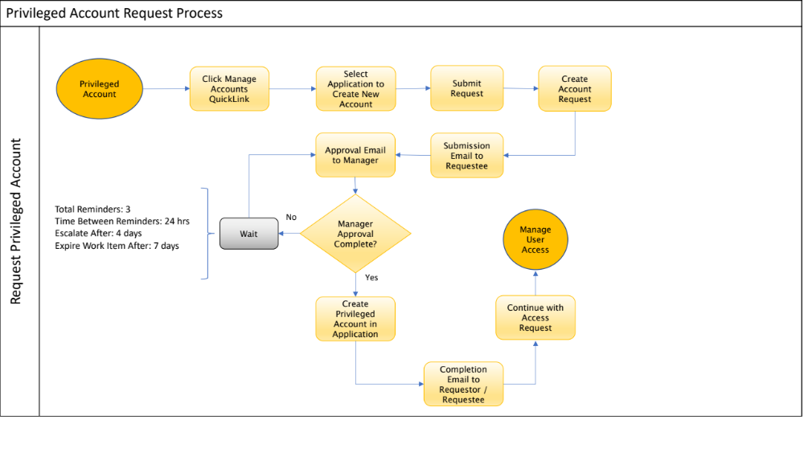

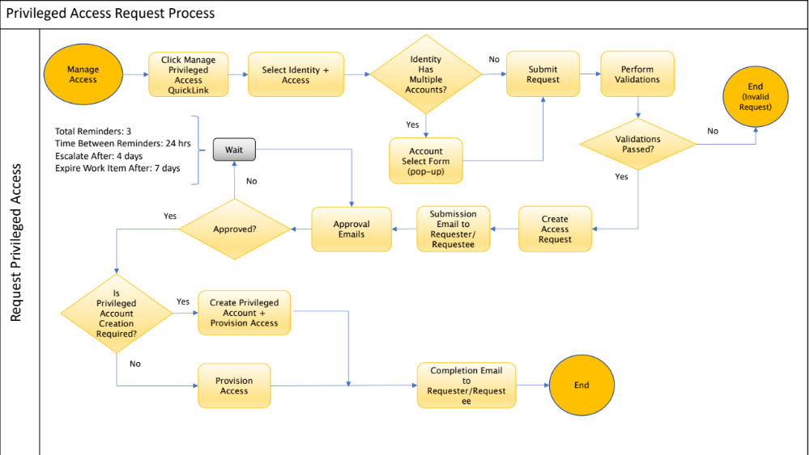

Privileged Account Bypass Manager Approval
Manager Approval can be bypassed by setting the Boolean extended attribute “omitmanagerPrivgaccess” value to “True” on an application object.

Privileged Account Certification
Privileged Roles and Entitlements can be excluded from all types of certifications by using Accelerator Pack exclusion rules and by setting the “excludePrivilegedAccess” value to “TRUE”. This parameter is defined in a custom artifact “Custom-Framework-Exclusion-Logical-BusinessApplications-PrivilegedAccess”.

Privileged Account Expiration Notification
A rule-based task definition “Privileged Account Password Expiration Notification” is designed to send out privileged account expiration notifications. This task definition references the rule “Rule-Framework-PSA-PasswordExpiration” that sends out password expiration notifications, reminders, and executes password expiration actions.

Here is the pseudo-algorithm
- Get All Password Expiration Enabled Applications. This is based on an extended attribute “enablepswexpNotification” that is defined on an application object
- Get All Links (Accounts) on applications that are privileged. This is based on an extended attribute “psAccount” that is calculated on a link object
- Find accounts that are about to expire. This is calculated based on applications password expiration attribute and password age.
  - The extended attribute defined on an application object for password expiration attribute is “pwdexpAttr”
  - Password Age can be calculated based on an extended rule or selected password age format options
    - The extended attribute defined on an application object for password age format is “pwdexpAttrexpression”. Here are the drop-down list values for this attribute
      - Windows NT Time Format
      - YYYYMMDDHHMMSST Format
      - Extended Rule
- Check to see if the account’s password expiration is before the password daily notification range. If yes, send out daily notifications. This is based on an extended attribute “beforepwdexpAttr” on an application object
  - This kicks off a workflow “Workflow-PSA-PasswordExpiration” that will send out email notifications to the correlated account identity cubes
- Check to see if the account’s password expiration is after the password expiration action range. This is based on an extended attribute “afterpwdexpAttr” on an application object. Take account action based on another extended attribute “afterPassExpProcess” on an application object.
  - Here are the drop-down list values for this attribute.
    - Scramble Password
    - Disable Account and Scramble Password
    - Do Nothing
  - Any of the above selected action kicks off a workflow “Workflow-PSA-PasswordExpiration” that would launch a provisioning plan to take action on action

For the Scramble Password Option, the Password Attribute is obtained from the extended attribute “scramPwdattr” defined on an application object. If not configured, another extended attribute “passwordAttr”is used that is defined for LDAP connectors on an application object. If not configured, the default ProvisioningPlan.ATT_PASSWORD constant is used.

Privileged Account Dependency on Features
Any account that is not privileged is considered a primary/regular account. Here is the list of Accelerator Pack Features that are dependent on the privileged account extended attribute “psAccount” on a link object.
- Mover
  - Before Mover Only Primary Account
- Joiner Rehire
  - On Rehire Restore Only Primary Account
- Attribute Synchronization
  - Only Primary Account Attribute Sync
- Password Synchronization
  - Detect Change Password on Primary Account

